LAB#1 WEB PROGRAMMING

CST8285 F2022



Lab#1 Web Programming

# LAB OBJECTIVE

The objective of this lab is to get familiar with the following:

1. About IP addresses and Domain Names
2. How to create HTML documents
3. Creating your first webpage using HTML tags:
4. Validate your HTML file

Earning

To earn your mark for this lab, each student should finish the lab’s requirements, submit your lab on the Brightspace and demonstrate the working code to the instructor.

STATEMENT OF THE PROBLEMs:

# Part A: Useful Commands (Don’t submit this part)

## ipconfig

The ipconfig command is a fast way of determining your computer’s IP address. Open the command window by either clicking a shortcut, or typing *cmd* in the *run* window, Into the cmd window type

### Ipconfig

The output will include output showing your IP address

## nslookup

To determine the ip address for a domain name type:

### nslookup algonquincollege.com

Notice that the first part of the output lists your Server

## tracert

Tracert is a command which can show you the path a packet of information taken from your computer to one you specify. It will list all the routers it passes through until it reaches its destination or fails to and is discarded. In addition to this, it will tell you how long each 'hop' from router to router takes.

To trace the route from your computer to Algonquin college web site type

Page **1** of **6**

Lab#1 Web Programming

### tracert algonquincollege.com

What you are seeing in your output is the path your request took to get to the

webserver at algonquincollege.com. If a domain name is available, it will list it. If not, you will see an IP address. Some routers will simply show *** which indicates that there is either a problem, or firewall settings have been configured to prevent the router information from getting back to you.

# Part B: Inspect Your html File (Don’t submit this part)

* 1. Open your IDE
  2. Create a new folder/directory called *lab1* This is where we are going to store your work. 3- Create a new HTML (“first.html”) document with the following content:

<!DOCTYPE html>

<html lang="en">

<head>

<title>A very simple webpage</title>

<meta charset=" UTF-8" />

</head>

<body>

<h1>A very simple webpage. This is an "h1" level header. </h1>

<h2>This is a level h2 header. </h2>

<h6>This is a level h6 header. Pretty small!</h6>

<p>This is a standard paragraph.</p>

<h2>How about a nice ordered list!</h2>

<ol>

<li>went to market

<li> went to Web programming class

<li> went to restaurant

</ol>

<h2>Unordered list</h2>

<ul>

<li>First element

Page **2** of **6**

Lab#1 Web Programming

<li>Second element

<li>Third element

</ul>

<h2>Nested Lists!</h2>

<ul>

<li>Things to to today:

<ol>

<li>Walk the dog

<li>Feed the cat

<li>Mow the lawn

</ol>

<li>Things to do tomorrow:

<ol>

<li>Lunch with mom

<li>Feed the hamster

<li>Clean kitchen

</ol>

</ul>

</body>

</html>

4- Save your file and test file in browser 5- Open this webpage in **CHROME**

1. Right click on the page and select *View Page Source*
2. Go back to the webpage view Right click on the page and select inspect This should open a little window at the right-hand side of your web page. In Chrome is called the DevTools window.
3. Look at the DevTools window and play with its tabs.

# Part C: Validate Your html File (Don’t submit this part)

One way that professional web developers catch errors in their markup is to validate

their documents. What does that mean? To validate a document is to check your markup to make sure that you have abided by all the rules of whatever version of HTML you are using

1. Open a browser and go to [http://validator.w3.org](http://validator.w3.org/).
2. In the Validate By File Upload tab, click the Browse or Choose File button and choose your “first.html”file.
3. Click the Check button. The site should eventually verify that your page is valid. You may

or may not get a warning, but some of the warning are relatively unimportant.

Page **3** of **6**

Lab#1 Web Programming

1. Remove the closing </ul> element, save, and then redo steps 1-3 of this exercise.
2. The page will not be valid, and the service may find not one but many errors. At the time of writing, the validator lists the missing </ul> element as error number 10. Thus, while a validator can help you find an error in your markup, the error messages do take some interpretation.
3. Put the closing </ul> tag back in, save, and re-validate.
4. Try to remove other html tags and re-validate to get familiar with the validator.

Page **4** of **6**

Lab#1 Web Programming

# Lab Exercise: Building a webpage from scratch (you should submit this part)

Create a web page “hometown.html” **about your hometown**. The image below is just example, you should create a similar webpage including information about your townhome.

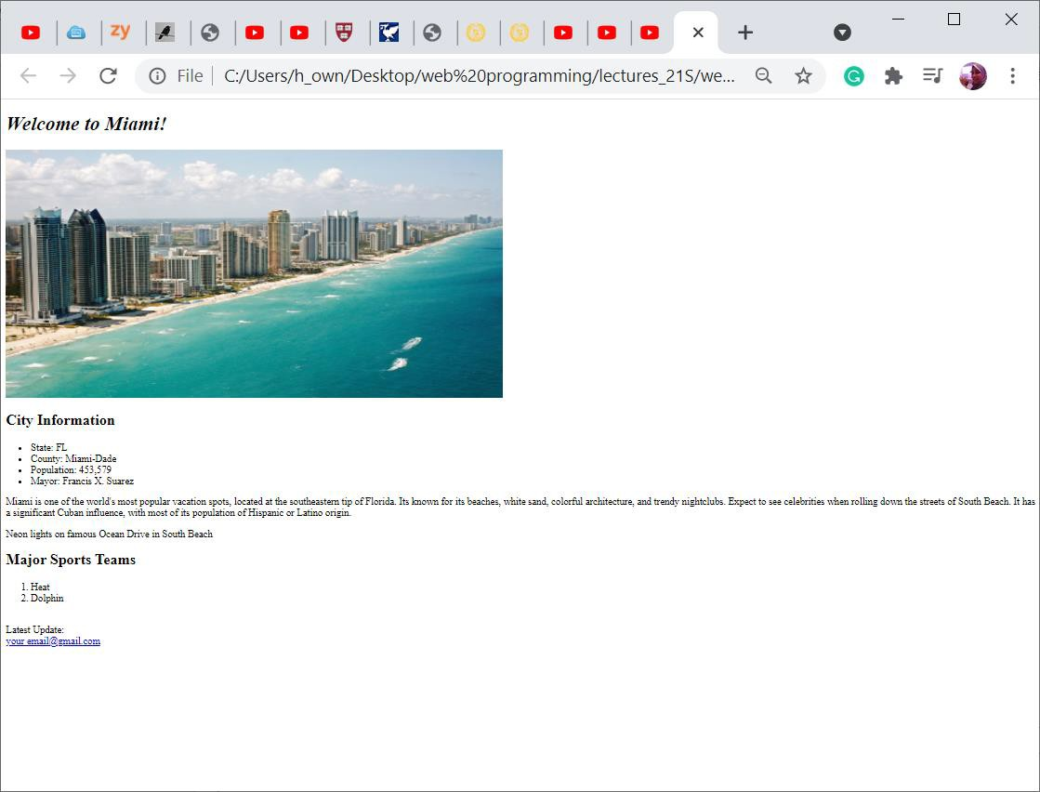

To earn the full mark for that lab, Be sure to include the following:

* Include the doctype.
* Include a title.
* Level-one heading for the town name.
* Level-two heading for the City Information
* Level-four heading for last Updated
* Paragraphs
* Image with alternative text.
* Ordered list
* Unordered list
* bold-face text
* Indent code correctly.

Page **5** of **6**

Lab#1 Web Programming

* Validate your page using the [W3C Validator.](http://validator.w3.org/) Submit a screenshot for the validation results

Other Important Requirements

* Demo and justify your work and provide correct answer to professor questions.
* The work will be graded zero if you do not demo it on time, even if uploaded.

Submission

To submit the lab on the Brightspace, you must upload “hometown.html” file and validation screenshot image in a .zip. The zipped file must be named the following:

<First Name>_<Last Name>.zip

Note that <First Name> and <Last Name> should be replaced with your first and last name.

Page **6** of **6**